Program: Submitting Conflicts

- Log onto the CAPTE Portal
- On the “Upcoming On-Site Visits” tile
- Click on the visit date you need (There should only be 1 date on the tile, or 2 dates if your program has an expansion

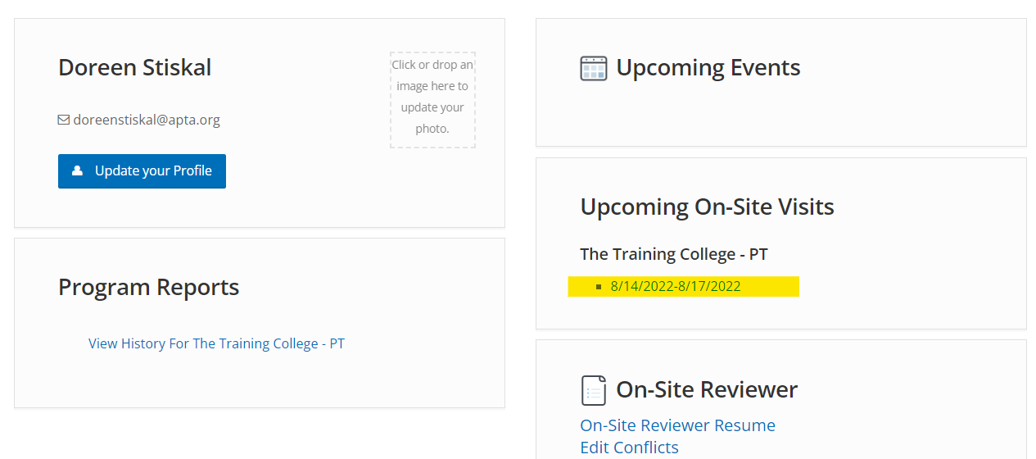

- Click “Edit Conflicts” - it may take a minute to produce the list of onsite reviewers

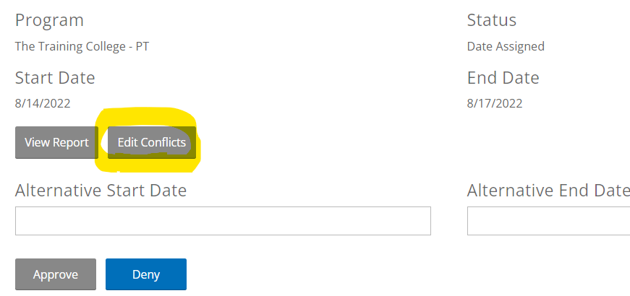

- Once the list of onsite reviewers appears, check the boxes next to onsite reviewers who are in conflict with the program
- When finished, click on the empty gray box next to Finalize Conflicts and then click Finalize Conflicts.

- You can either log off or go back to the home page on the portal
- NOTE: The “Add Conflicts” button is only used if you want to add a conflict and then come back later to complete your conflict list.

