- Log onto the CAPTE portal
- Go to the “Upcoming On-Site Visits” tile and click on the date of the onsite visit
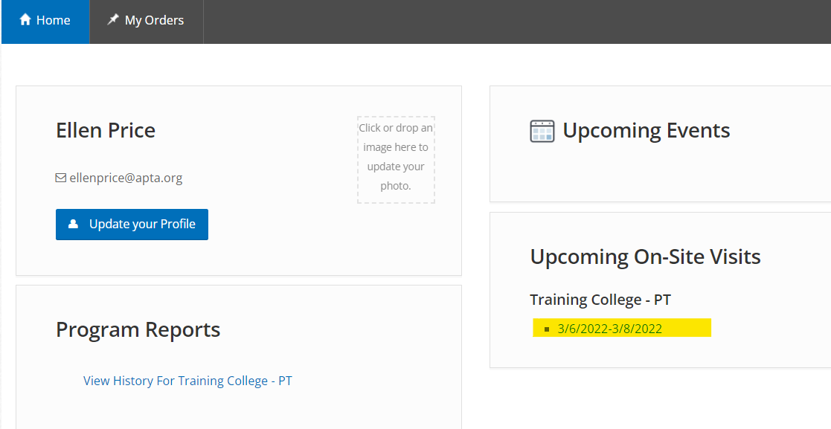

- The start and end dates for the onsite visit have been provided for the visit you chose
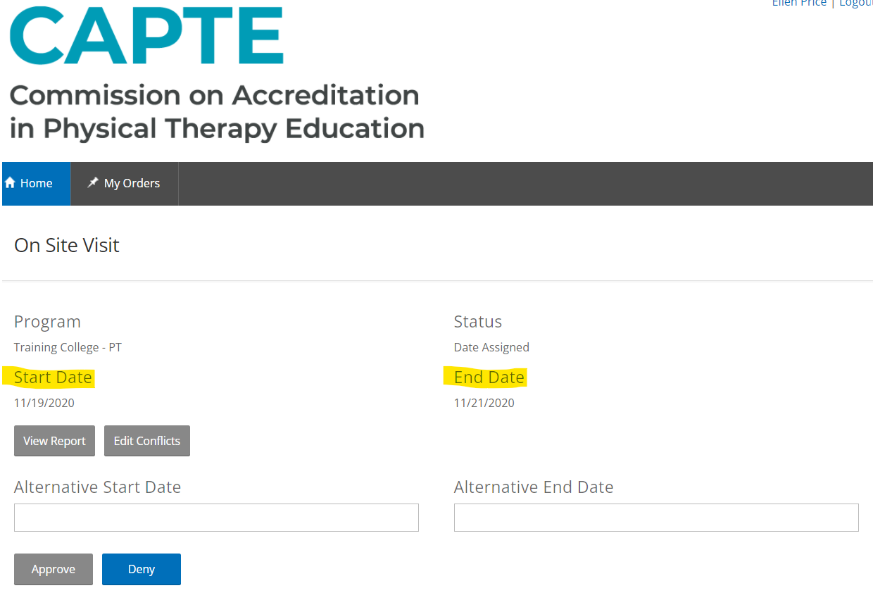

- If you approve of the visit dates, then please hit approve
- You will then see a message in blue on the screen saying your visit dates have been approved
- The process is now complete. You can either log-out of the CAPTE portal or return to the home page

If you do not approve of the visit dates:
- Please enter alternative dates which work for your program.
  - The dates should start on a Sunday and end on a Wednesday.
  - If your program has an expansion, then the visit will end on a Thursday.
- Then click on the blue “Deny” button

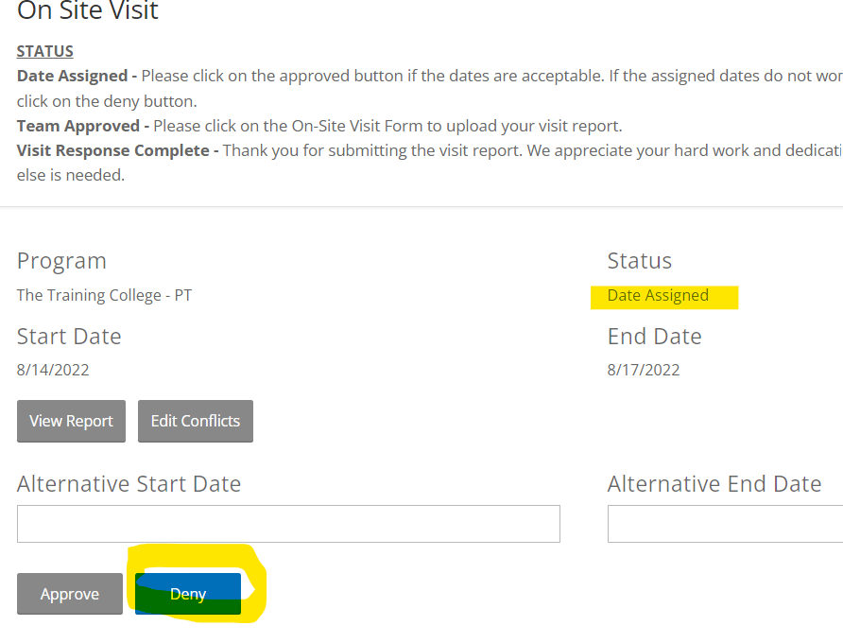

- You must click the Deny button or CAPTE will not be notified that you have denied the suggested visit dates
- You will then receive a message at the top of your screen saying the Denial was recorded
- The Status of the onsite visit will change from “Date Assigned” to “Date Pending”
- This signals to CAPTE staff that the visit dates have been denied and new dates were provided
- CAPTE staff will either approve the new dates or provide the program with their final alternative dates. In either scenario, the program will be notified of the final dates

